 [Translated from Dutch to English - www.onlinedoctranslator.com](https://www.onlinedoctranslator.com/en/?utm_source=onlinedoctranslator&utm_medium=docx&utm_campaign=attribution)

Question 1

A 2-dimensional point can be represented as a tuple where the first number is the x coordinate and the second number is the y-coordinate. A figure can be represented as a list of points. A figure consists of at least two different points. If the figure consists of more than two points, the last point may never be equal to the penultimate point.

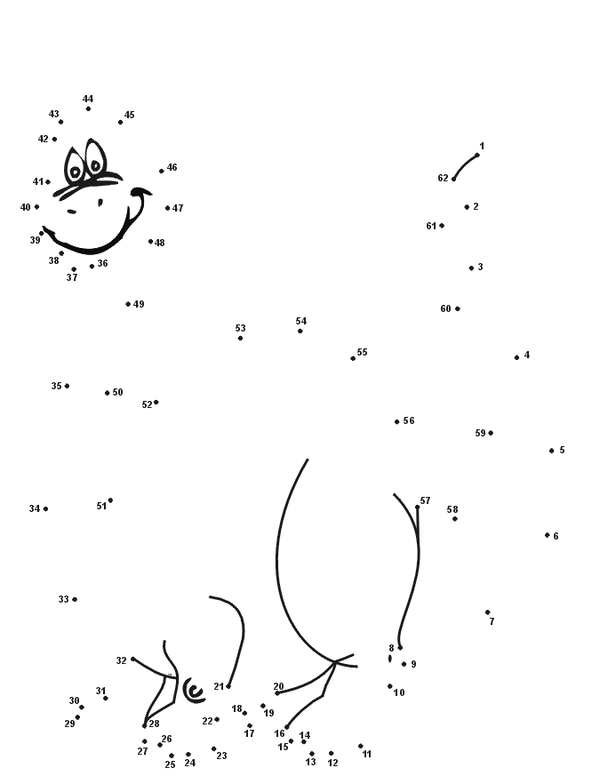

*Source:*[*https://www.kids-n-fun.nl/knutselenpuzzel/puzzels/verbind-de-puntjes/119/een-vrienden-vuurspuger*](https://www.kids-n-fun.nl/knutselenpuzzel/puzzels/verbind-de-puntjes/119/een-vriendelijke-vuurspuger)

* Write a function create_point that, given two integers, returns a tuple corresponding to the point with x_coordinate as the first number and y-coordinate as the second number

* Write a function that, given two tuples of points (x1,y1) and (x2,y2), returns the distance between these two points (formula distance = square root((x2 – x1)² + (y2 – y1)²)
* Write a function is_equal that, given two tuples of points, returns whether these two points are equal
* Write a function create_figure that, given two tuples of points, returns a list consisting of these two points in given order; the two given points may not be equal. The function returns False when the 2 points are equal.
* Write a function add_point_that given a figure (i.e. a list of points) and a tuple (corresponding to a point) adds another point to the figure; the point to be added may not be equal to the last point of the figure. The function returns True if successful, False otherwise.
* Write a function lengths that, given a figure, returns a list of integers that correspond to the respective lengths of two consecutive points in the figure (the lengths are rounded up; use the ceil function from the math module for this).